

Date | 30 September 2026
Team ID | SWTID-2026-3972
Project Name | Import Data using Transform Maps (Spreadsheet)
Team Leader | Kartheeswaran M
Team Member | Karuppasamy A
 | Mari Muthu G
 | Irfan U
Maximum Marks | 5 Marks

Project Title:
Import Data using Transform Maps

1. Brainstorming & Ideation Phase

The project is based on improving the process of migrating bulk employee data into the ServiceNow platform. The existing process of managing employee data manually in spreadsheets is prone to errors, time-consuming, and can lead to data duplication. The project idea was developed to reduce this manual overhead by automating the data import process using ServiceNow's native capabilities.

The main idea is to use ServiceNow Import Sets and Transform Maps to load external Excel data into a staging table and seamlessly map it to a target custom table (Employee Test). This automated mapping ensures that employee details such as ID, Name, Email, Department, and Location are accurately transferred into the system.
The project user story is: As a system administrator, I want a streamlined process for importing bulk employee data from external sources so that records are automatically created or updated in the target table without manual entry. This is intended to maintain data accuracy and save time.

The proposed solution focuses on creating a seamless data migration experience, reducing potential errors caused by manual typing, preventing duplicate records through 'Coalesce', and enhancing data visibility by generating real-time reports and dashboards.

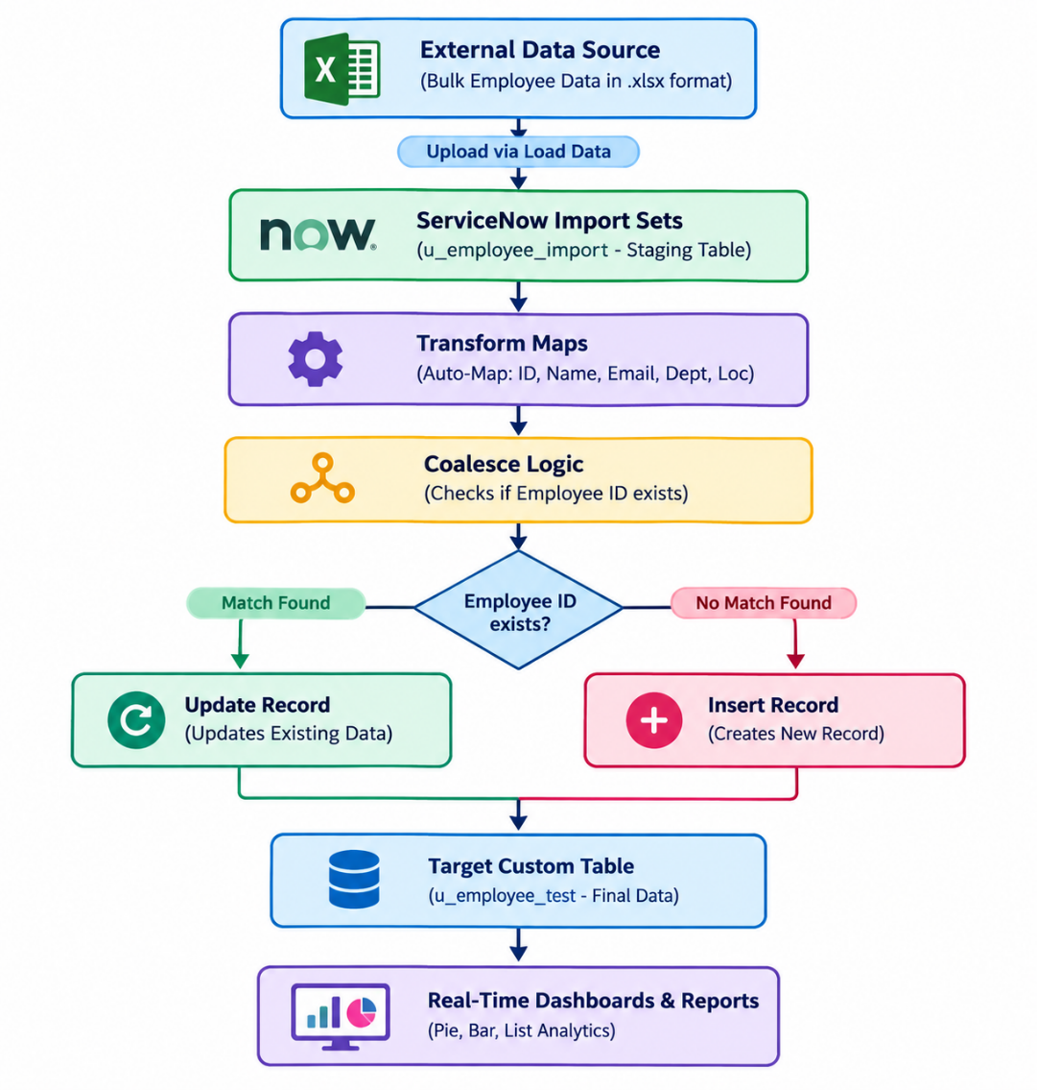

Screenshot:

